Greetings from Visas Avenue!!
Thank you for considering Visas Avenue.
We are global leader in providing best on-line immigration solutions. We provide immigration assistance to different countries across the globe. We have a sole purpose of helping people achieve their migration goal with ease. Along with the excitement of change, immigrating to a new country can sometimes be a daunting process, as it is filled with challenges. Hence we seek to minimize these challenges, particularly the confusion and frustration at is often associated with the visa application process. Our sole goal is to allow our clients the freedom to focus on the excitement of immigrating to another country and dedicate ourselves to take care of their migration or visa process and make their dreams come true.
Facilities / *Benefits given by Canadian Government:
- Life time visa
- Free health benefits
- Free education up to higher secondary diploma.
- Spouse is eligible to work on the basis of same visa
- Unemployment funds
- Retirement funds
- Can apply for citizenship
- Free access to US after few years stay in Canada.
* Benefits are subject to Individual Conditions
ADVANTAGES OF EXPRESS ENTRY VISA
- Government of Canada, provinces and territories (P/Ts) and Employers will have a direct role in economic immigration
- Express Entry system eliminate backlogs and introducing processing times of six months or less.
- Allowing for greater flexibility
How to start the process for Canada Express Entry visa
Get a free assessment done today!! To check your eligibility for Visa application & for your assessment kindly share your resume & furnish the below mentioned details:
Marital status:
If married, Spouse highest qualification: Relative in Canada/Australia:
Work ex in Canada:
Studies in Canada:
Visas Avenue fees
One shot – 70,000 + Service Tax at actual.
(Detailed services will be given in Review Report)
Once you decide to take-up our services you need to sign a fee agreement with us. This is about what services we are going to provide you before immigration. This agreement explains and provides you details of all services we are offering to our clients. Once sign the agreement then we will appoint a case manager for you who will guide you in each and every manner for following processes.
1. Application Process and appropriate fee of 227 CAD - 750 CAD towards concerned Educational Assessment Authority of Canada (Duration: 45 days)
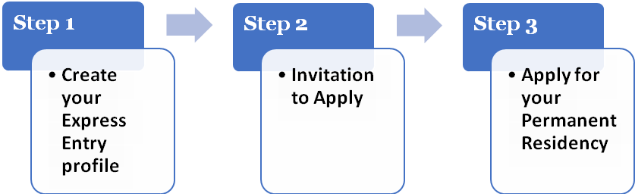
- Potential candidates will submit an online Express Entry profile. They will be assessed according to a skills based ranking system. Candidates who meet the criteria of one of the federal economic immigration programs subject to Express Entry will be placed in the (EOI) Expression of Interest or also known as Express Entry pool.
- You will be offered an Invitation to Apply (ITA) for permanent residence (PR) based on your CRS (Comprehensive Ranking Score)
•Candidates with an ITA will have 60 days to apply for permanent residence along with visa processing fee (VPF) CAD 550 per person older than 22 years & CAD 150 per person less than 22 years payable to the concerned visa authorities.
- Applicants will need to meet the criteria set out in the immigration program which applies to them. After scrutiny by IRCC you need to pay the Right of Permanent Residence Fee (RPRF) of CAD 490 per person older than 22 years.
- The Canada High Commission/IRCC may call you for an interview. If everything is verified by IRCC, you will then be asked to send in your original passports and photograph. Your visa is stamped and your passport and COPR is mailed to you.
A prompt and early decision by you to begin the immigration process will benefit you because the earlier the better. So we advise you to do the assessment so that we can start the process soon.
Please do not hesitate to get in touch if you have any further queries.

